Muscle Regeneration Could Be Achieved Within The Body
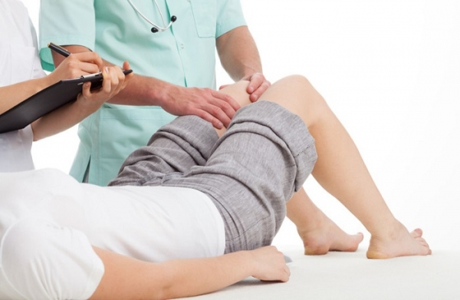

Researchers could regenerate muscles within the body by employing some of the body's natural healing powers.
A Wake Forest Baptist Medical Center's Institute for Regenerative Medicine study showed the ability to recruit stem cells that can form into muscle tissue when attached to small piece of biomaterial, or "scaffolding." They accomplished regeneration using proteins involved in cell communication and muscle formation.
"Working to leverage the body's own regenerative properties, we designed a muscle-specific scaffolding system that can actively participate in functional tissue regeneration," said Sang Jin Lee, Ph.D., assistant professor of regenerative medicine and senior author. "This is a proof-of-concept study that we hope can one day be applied to human patients."
The current method for restoring function when large chunks of muscle are injured or removed is to surgically remove muscle from another part of the body and transplanting it in another; the problem is this also reduces functionality at the donor site. Scientific teams have also been taking biopsies of cell tissue, expanding them in the lab, and placing them on scaffolding for implantation.
"Our aim was to bypass the challenges of both of these techniques and to demonstrate the mobilization of muscle cells to a target-specific site for muscle regeneration," Lee said.
Most tissues in the body contain tissue-specific stem cells believed to be "regenerative machinery" that works for tissue maintenance; the team attempted to mobilize these cell. They implanted scaffolds into the lower legs of rats and reexamined after several weeks.
The trial revealed scaffolds contained "muscle satellite cells as well as stem cells that could be differentiated into muscle cells in the lab." The scaffold also developed a network of blood vessels that were fully mature only four weeks after implantation.
The team also looked at the effect of several proteins known to be involved in muscle formation by designing scaffolds that release said proteins. The protein that was found to have the strongest effect was the insulin-like growth factor 1 (IGF-1).The study revealed scaffolds with IGF-1 had up to four times the number of cells than regular scaffolds.
"The protein effectively promoted cell recruitment and accelerated muscle regeneration," Lee said.

